Church of St. John & St. Mary
HOLY WEEK SCHEDULE
*Please note that all CDC and NY Archiocesian Covid 19 Guidelines will be followed for all Masses and services.
+ PALM SUNDAY MASSES +
5:15 Saturday Vigil Mass: Upper Church
SUNDAY MASSES:
7:30 AM – Little Church
10:00 & 12:00 Noon Masses
Upper Church

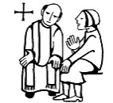
+ RECONCILIATION MONDAY +
4:00 PM – 5:00 PM
7:00 PM – 8:00 PM
Upper Church

+ DAILY MASS+
Monday – Wednesday
8:30 AM – Upper Church
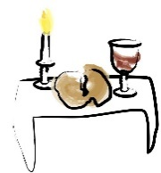
+ HOLY THURSDAY +
7:30 PM – Mass of the Lord’s Supper
Upper Church
Followed by Adoration of the Blessed Sacrament
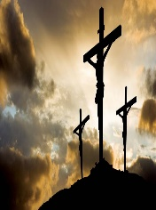
In the UPPER CHURCH

+ GOOD FRIDAY+
3:00 PM - Friday of the Lord’s Passion
Upper Church
7:30 PM – Stations of the Cross
Upper Church

+ HOLY SATURDAY +
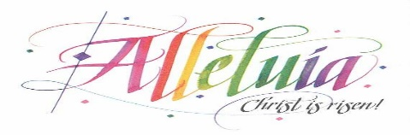
The Easter Vigil Mass
8:00 PM – Upper Church

+ EASTER SUNDAY MASSES +
7:30 AM, 10:00 AM and 12:00 Noon
Upper Church

